Isaac Hoyt
Team 5 Alcon
3/12/2025
BME 180B
HW 4
Part 1

Hardware: 3D printed parts (PLA), a stage controller, polarizer sheet, and re-used Arduino components from Arduino Starter Kits (wires, stepper motors, etc), re-used Arduino Mega 2560
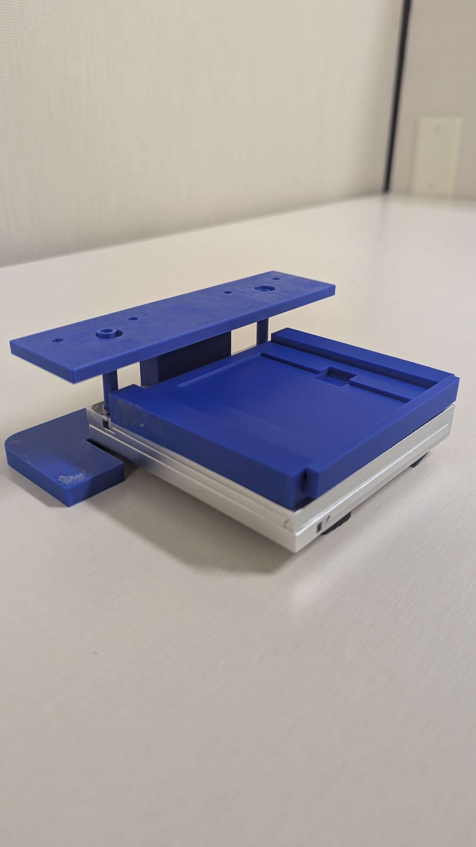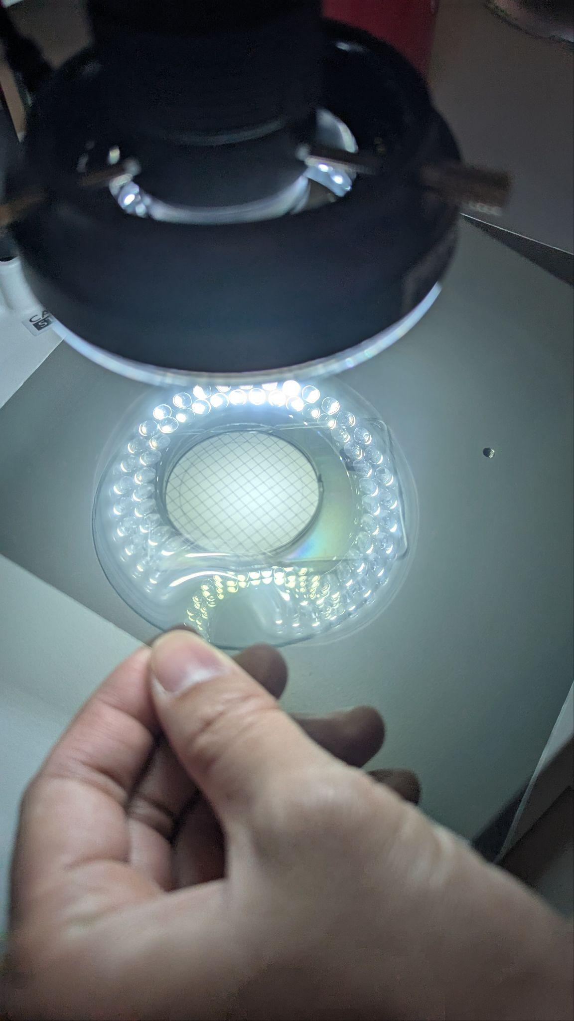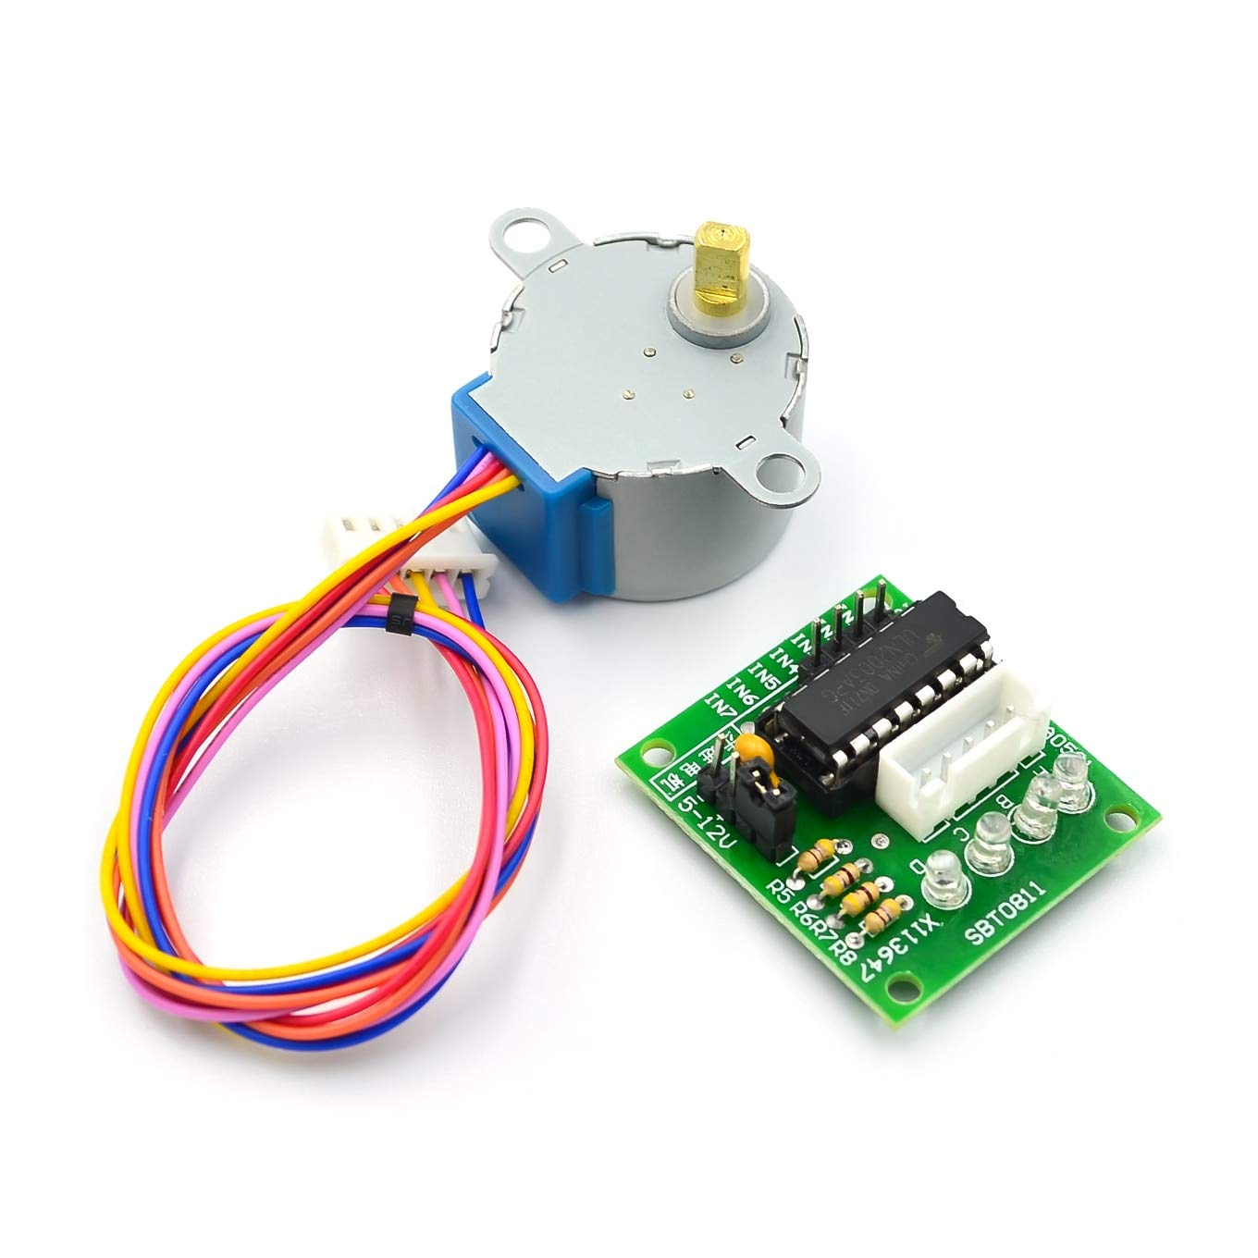

Software: Yolo, OpenCV, Pytorch (all free)

First Generation Prototype
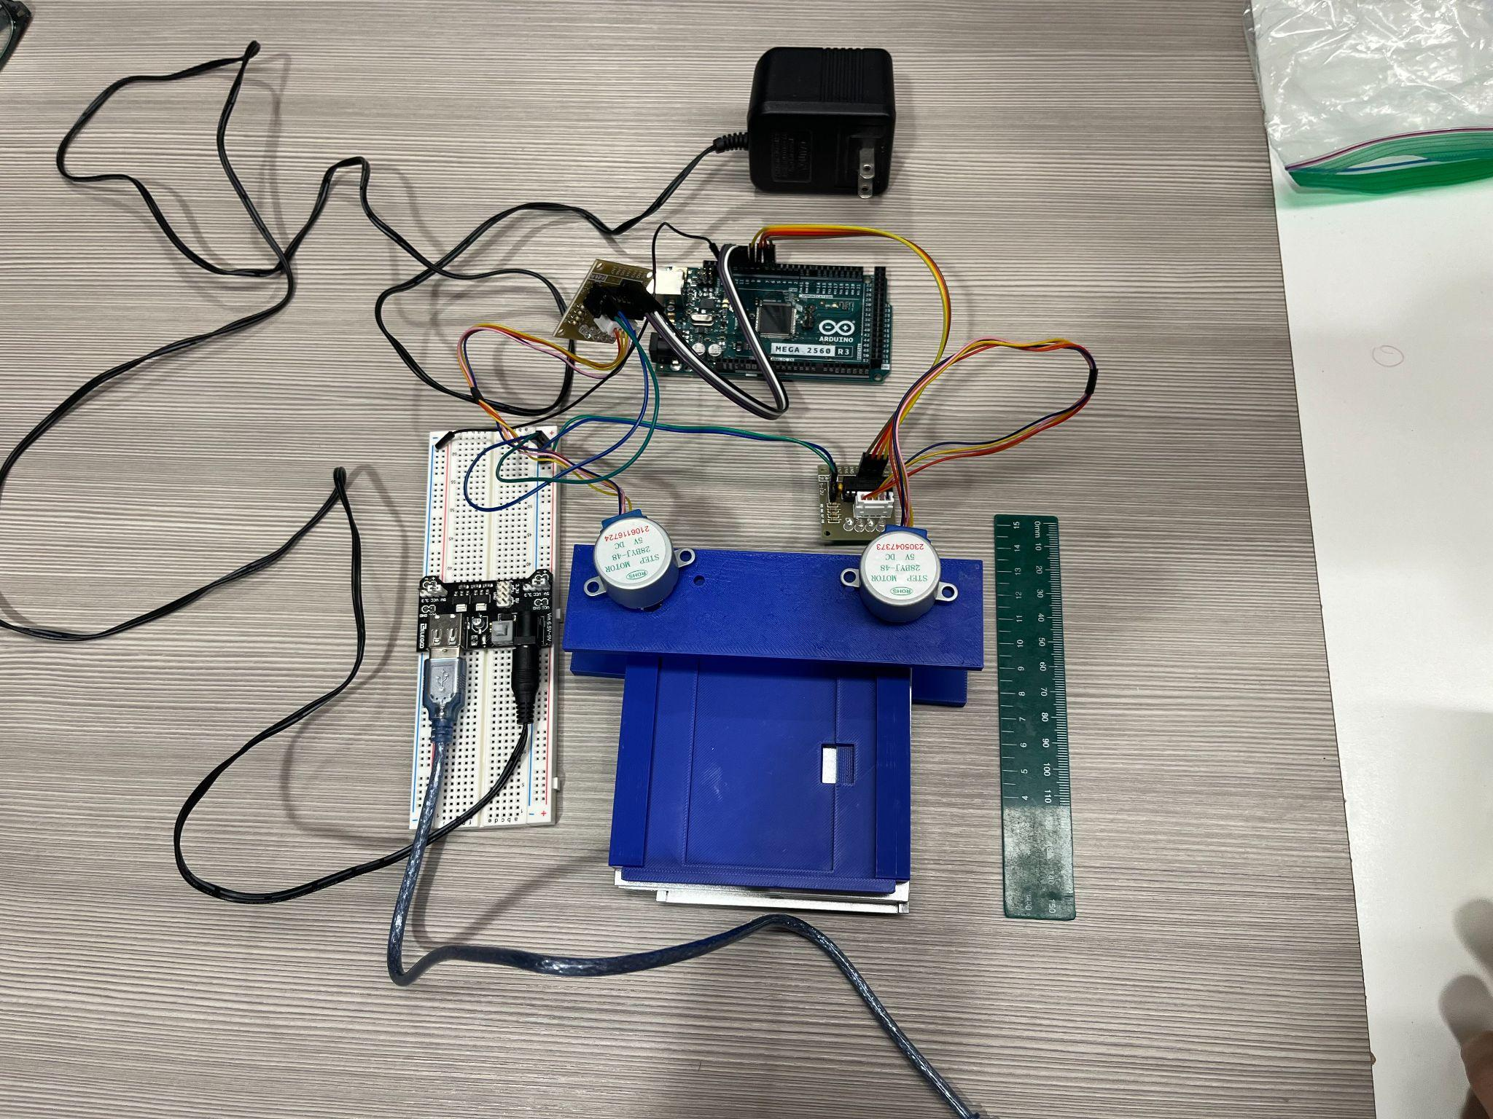

For our first generation prototype for the hardware side, we have successfully fabricated and assembled what the automatic stage controller will look like with all the parts attached. The 3D printed parts were made out of PLA. The picture above also includes the stepper motors and its circuitry courtesy of the Arduino Starter Kit. For the controller, we used an Arduino Mega 2560 for its stronger processing power.
Although we have yet to train the YOLO model on a custom data set, we have successfully set up the base pre-trained YOLOv5 model. In addition, the image acquisition portion of our software successfully captures images from a video feed. Ultimately, we hope to send these images to a custom-trained YOLO model that can identify and measure any titanium particles therein.
Part 2
Projects Criteria:
For our prototype, we decided to split the design criteria into two categories because the design requirements for the hardware and software are so different from each other.

Hardware Criteria
Precision and Accuracy | Ability to accurately pinpoint and survey the entire particulate filter  - Movement of the stage controller should have a margin of +/- 0.5 cm per intended distance travelled  Pass/Fail
Automation Capability | Ability to reduce manual work for analyzing the particulate filter  - Can the stage controller allow the software to take all areas of the filter?  Pass/Fail
Cost Effectiveness | Total cost of the method with 5 being the most cost effective strategy  Cost < $2000
Speed of Operation | Time it takes to scan the entire area of the particulate filter  Time < 5 minutes per handpiece
User-Friendly Interface | How easy and accessible it is to use the method  - Ask technician if there is something in the process that would ease the process, labor wise or time wise  - Survey for technician with prototype - make a measurement where they can show how what we did improved their process  Pass/Fail
Maintenance Requirements | How easy and efficient to maintain the system  - Survey for technician with prototype regarding the number of instances where they did an action that would keep the system in good shape  Pass/Fail

Software Criteria
Particle detection automation | Alert only when technician is needed  Pass/Fail
Particle detection accuracy | Must be within 5% of technician’s counting accuracy
Particle size measurement automation | YOLOv5 will tally each identified particle  Pass/Fail
Particle size measurement accuracy | Must be within 15% of technician’s counting accuracy  Pass/Fail
Integration with existing hardware | Must be plug-and-play, should not unnecessarily increase amount of hardware needed for test  Pass/Fail
Image processing speed | Should be faster than or equal to technician, following a time study  Pass/Fail
Store and track particle data | ID number, centroid location, size measurements are shipped back to documentation  Pass/Fail
User-friendly interface | Generates report for technician in accordance with YOLOv5 measurements  Pass/Fail

1. What parts of the design pass your design and acceptance criteria?

Although our prototype is non-functional at the moment, some aspects of our design pass our criteria. Specifically, our cost criteria, maintenance scheduling, and image compiling are going well. In terms of cost, our production is significantly cheaper than expected, consisting of a handful of 3d printed parts, Arduino circuit components, and an inexpensive stage controller. All in all, this totals out to less than $150. As for maintenance, the simplicity of the design allowed us to check for worn-out components and tolerance issues – making identification of problems much easier. Lastly, for image compilation, we found success in this portion of the software through its success in properly shipping a compiled-image folder to YOLOv5. As for the image capturing test, we have tested the image acquisition separately from the prototype and the results came out successful; however, we only tested it on the webcam, not the microscope.

2. What parts of the design fail your design and acceptance criteria?

In spite of the successes, we do have some critical setbacks that are preventing our device from working properly – these include Arduino issues and image capture issues on top of a technician needing to oversee the process.
The Arduino issues we were experiencing came from both circuitry and serial connection issues. We were not initially expecting to have connectivity issues between the computer and the Arduino, however we will be working on that promptly to ensure that our device works. For circuitry, we were originally able to receive power to the motors but are now having problems with that – preventing us from being able to use the motors.
A rollback state with the most basic circuit possible with one motor instead of two as well as a prewritten code was used to verify that our motors and other components work as intended; despite this, we were still unable to operate the motor as intended. This could mostly likely be a result of faulty components and as such we will swap components with new ones to ensure our hardware is viable.
It is due to these complications that image acquisition is being delayed – we are unable to capture images using the device. What this means for YOLOv5 is that we are forced to use manually taken photos for training data instead of device-captured images. This will allow us to continue training the A.I. model and continue development of the device.
In terms of automation, the device is still intended to be automatic. However, there is still a need for technician intervention. Currently, they are responsible for loading of the filter slide, starting the code, and monitoring the device as it runs.
For monitoring, we believe this to be less of an issue as the technician should be able to monitor multiple instances of the device at once, preventing delays of the process. However, the biggest issue right now is that there is no way of indicating or warning the technician that an error has occurred – this means that the technician would have to run the whole process before finding out something has gone wrong. For the loading and starting of the code, this should be smooth and easy, but it is extra steps that would have to be manually taken to begin the process, reducing the amount of automation.

3. Using your limited resources, what “expensive” or “hard to find” parts or software are
absolutely needed?

The stage controller is the most expensive component of our device. It is roughly $50 USD and has a lead time of about 1.5 weeks. This means that any new stages that we intend to purchase will take longer than anything else to arrive – increasing production time of each device.
Further, our 3D printed components are bespoke – unique to the device with no current off-the-shelf equivalent – both to the device as a whole and to our specific stage controller. This also means that our 3D printed components must be made in-house, there is no option to purchase these.
Our circuitry is made up of basic Arduino Starter Kit Components and is easy to acquire almost anywhere.
Lastly, our software is both python and arduino – free software that can be downloaded to any computer.

4. What worked on your prototype?

The polarized filters worked the most out of our design – they were the simplest and had the most clear criteria for success. It increased the contrast of the particles against the filter and allowed both people and YOLOv5 to more easily distinguish metal particulates.
Our 3D printed hardware components came out as intended as well. They came out to the specified dimensions and assembled as intended. However, they do not completely function as intended but that is a design issue and not a parts issue.
Our python code was able to compile images and send them to YOLOv5 and delete all images after the end of the testing process, working as intended.

5. What didn’t work on your prototype? Why?

Establishing communication between our software to the Arduino Circuit did not work as intended. As far as we were able to tell, our circuit should have been correctly assembled but continued to not work – even in the most basic state. Further, we are still having connection issues between the Arduino and the computer’s software. This could be due to our improper circuitry or a problem with our code – this will require more troubleshooting and we will need to put effort into resolving the issues related to these above problems. The problems listed here are the main contributors to our device’s non-function. After resolving these main issues we should have an easier time developing and iterating our device and its components.

6. What were your major failure modes?

When evaluating the hardware components of our design, several major failure modes must be considered. One primary concern is mechanical failure, which could occur if a component locks up, preventing the stage controller from moving. This would lock the microscope field of view in place, thereby disrupting image acquisition. Another risk to consider is wear on interfacing surfaces, particularly in 3D-printed components. Over time, repeated use could weaken these parts, ultimately affecting the image acquisition process. Without reinforcement or improved material selection, this wear could lead to misalignment or inconsistent stage controller movement. Additionally, a failure in the stepper motor driver, which is indicated by the LED not lighting up, may indicate that the driver chip or other components of the circuit board could be damaged.
In the software component, the primary failure modes involve eros in particle identification and measurement. The YOLO model, which is responsible for detecting titanium particles, may incorrectly classify objects, which could lead to false positives or false negatives. If the model fails to recognize titanium particles, the system may incorrectly assess a handpiece as passing the metal particulate test when it should not, which would significantly compromise patient safety. Conversely, if the model misidentifies non-titanium debris as titanium it could lead to the unnecessary rejection of handpieces, which owls reduce manufacturing efficiency. Of these two possibilities, false negatives are a much graver concern. Another concern is incorrect particle measurement, which would also affect the accuracy of the contamination assessment. Both failure modes undermine the reliability of the system.
Finally, human error introduces additional potential failure modes. Incorrect stage calibration can misalign the imaging process, causing inaccuracies in particle tracking and detection. Similarly, improper filter slide placement can shift the position of the sample.

7. How do you plan to address the issues that were identified?

To address potential hardware failures, we plan to establish a maintenance schedule focused on identifying wear and tear before it impacts performance. We will conduct weekly visual inspections and monthly functional tests to ensure smoother operation. These checks will allow us to detect early signs of degradation and replace faulty parts before they interfere with the test process.
For software-related issues, we will improve our YOLO model’s accuracy by expanding the training dataset. We will compare YOLO’s outputs with manual inspection results to assess performance. Additionally, we will fine-tune YOLO’s confidence threshold to balance false positives and false negatives, ensuring that only titanium particles are counted.
To resolve issues with the Arduino circuit, we will prioritize getting the stepper motor to move. Since the LED on the stepper driver does not light up, we suspect power delivery or hardware failure. We will use a multimeter to measure voltage output and check for continuity to determine if any connections are broken. If the stepper driver is confirmed to be broken, we will replace it entirely.
To mitigate human errors, we will develop comprehensive written guidelines in the form of a Manufacturing Operating Procedure (MOP) for our automated particle test equipment. Additionally, we will modify the existing Manufacturing Test Procedure (MTP) to incorporate our automated process. To further reduce misalignment errors, we will explore design modifications such as adding physical alignment markers for filter slide placement. These improvements will ensure consistent and accurate testing.

8. Put together a list of materials/items that are needed for your second generation prototype.

- YOLOv5
- New sets of particle training data (with polarizer)
- YOLOv11 if necessary
- Pytorch
- OpenCV
- OBS
- Alcon company laptop for onsite use
- Reiterated 3D printed parts
- New polarizing filter frame
- Arduino components (new sets of stepper motor driver circuits)

We may possibly need to acquire different motor components to those we already have due to technical difficulties with our circuit and its communication with the laptop’s code. We will be further testing our circuits to double-check that new components will not be needed.

